**Excel Fundamentals**

**Prepared by**



**Patrick Essien**

**DataSecFalcon**

[**cybersecfalcon@gmail.com**](mailto:cybersecfalcon@gmail.com)

**April 24, 2024**

**Project Overview:**

This project aims to demonstrate proficiency in fundamental concepts of Excel, including cell references, comparison operators, basic functions, and formulas. Through a series of tasks and explanations, this submission showcases the ability to manipulate data, perform calculations, and analyze information using Excel.

**Task 1: Explain what a cell reference is in Excel and why it's important in creating formulas and functions.**

Cell references in Excel denote the address of a cell, such as **F2** or **G2**. They are crucial in creating formulas and functions as they define which cells to operate on. For example, **=F2+G2** adds the values in cells **F2** and **G2**.

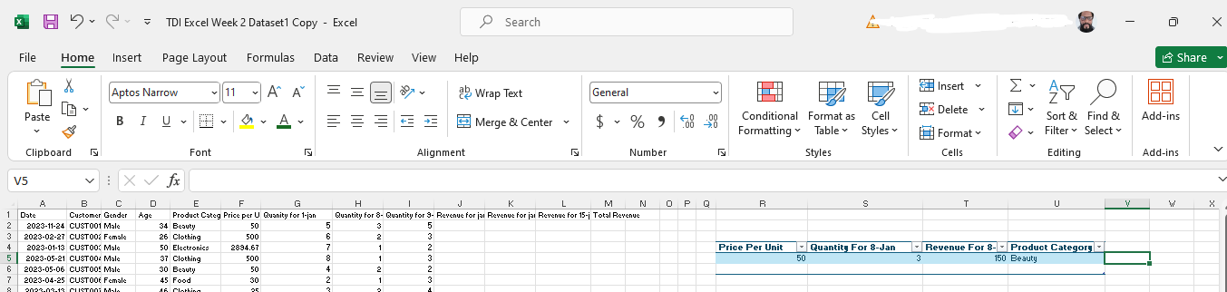

**Task 2: Differentiate between relative and absolute cell references in Excel. Provide examples of when each type of reference would be used.**

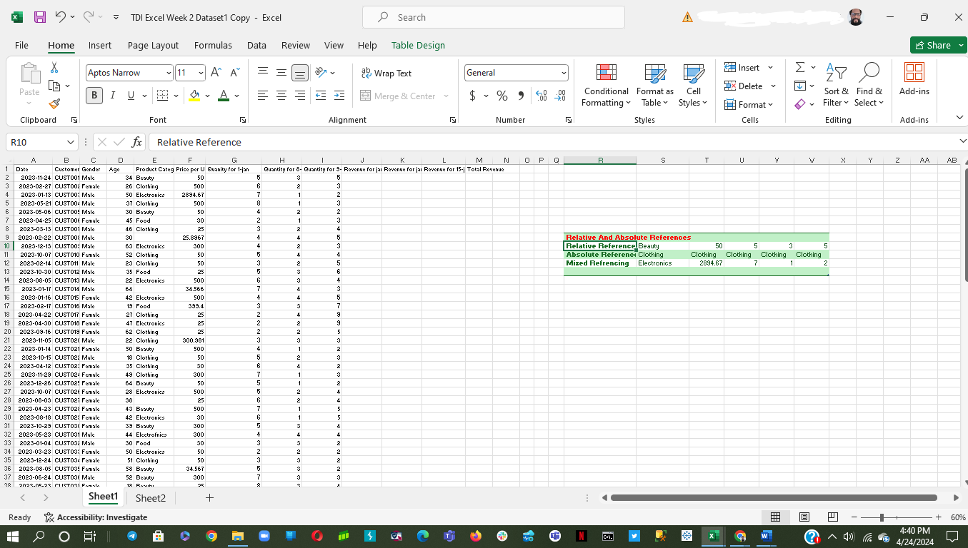

Relative cell references change when a formula is copied to another cell, while absolute cell references remain fixed. For instance, **=$E$3** always refers to cell **E3**, while **E3** changes based on the destination cell. Absolute references are used when you want a formula to always refer to a specific cell, like a tax rate.

**Task 3: Discuss the significance of mixed cell references in Excel formulas and how they differ from absolute and relative references.**

Mixed cell references combine aspects of relative and absolute references. They fix either the row or column while allowing the other to change. For example, **E$4** fixes the **row** (4) but allows the **columns** to change, handy for applying formulas across columns.

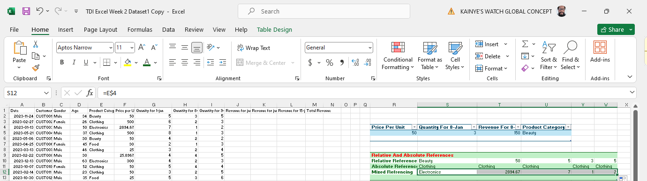

**Task 4:** **Calculating Total Revenue for Transactions where quantity of products is >10**

This involved creating a new column named **"TOTAL QUANTITY"** in the dataset and then filtering the data to calculate total revenue based on certain criteria. Below is a detailed description of how the problem was solved:

1. Creation of the **"TOTAL QUANTITY"** column:
   * A new column called **"TOTAL QUANTITY"** was created to aggregate the quantities from three different dates: **jan1, jan8,** and **jan15**. This was achieved by summing the quantities in each row using appropriate spreadsheet functions.
2. Filtering rows based on total quantity:
   * After creating the **"TOTAL QUANTITY"** column, the dataset was filtered to include only rows where the total quantity was **> 10**. This was accomplished using **conditional statements** or **filtering functions**, ensuring that only relevant data was considered for further analysis.
3. Calculation of total revenue:
   * With the filtered dataset, the total revenue was calculated by multiplying the quantities by their corresponding prices and summing them up. This step involved utilizing mathematical operations and appropriate spreadsheet functions to accurately compute the total revenue based on the filtered data.

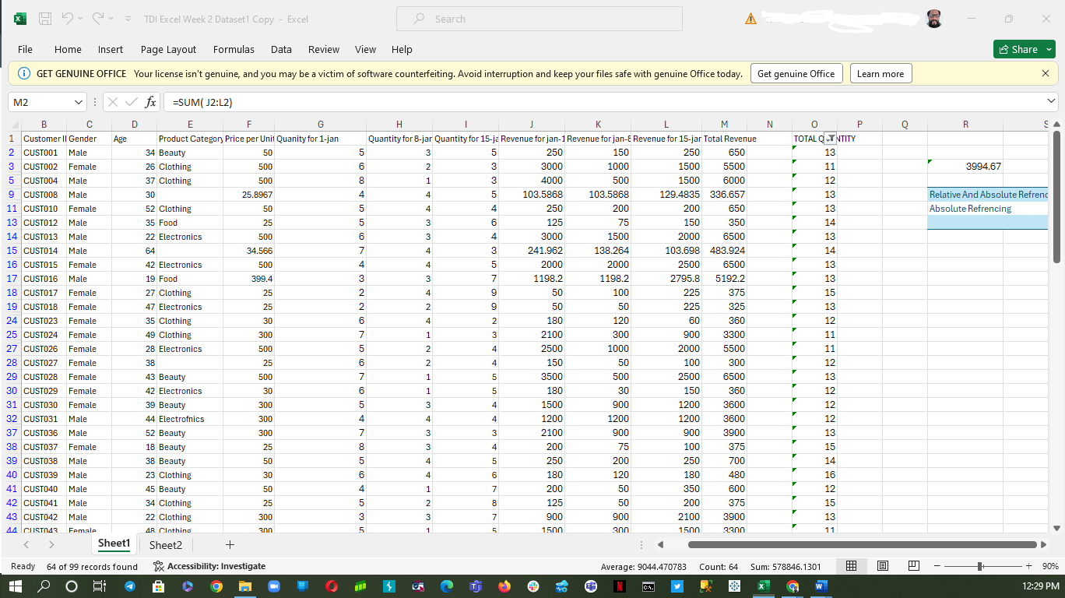

**Task 5: Explain the difference between a formula and a function in Excel. Provide an example of each using the dataset.**

In Excel, a formula and a function serve similar purposes but differ in their usage and implementation:

A formula in Excel is a combination of symbols, cell references, constants, and operators that perform a calculation. It begins with an equal sign **(=)** and can include arithmetic operations such as addition **(+)**, subtraction **(-)**, multiplication **(*)**, division **(/)**, as well as functions. Formulas can be simple or complex, depending on the calculation required. Formulas perform calculations on cell values (e.g., **=F2+G2**),

A function in Excel is a predefined formula that performs a specific operation. Functions are built-in tools provided by Excel to simplify complex calculations and operations. They accept arguments, perform calculations based on those arguments, and return a result. Excel offers a wide range of functions for various purposes, such as mathematical, statistical, logical, text manipulation, and more. functions are predefined formulas (e.g., **=SUM(F2:F6)**) performing specific calculations, and adding the values in cells **F2:F6**.

**Task 6: Use cell references to calculate the revenue for the first three transactions in the dataset (Jan 1,8 and 15)**

Calculate revenue for the first three transactions using cell references to quantity and price columns, multiplying and summing the results. **=SUM(M2:M4) =35096.7**

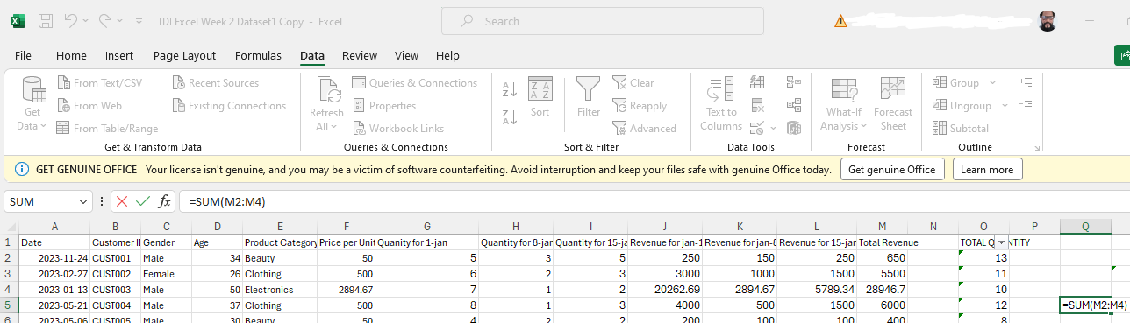

**Task 7: Create a formula to calculate the total revenue for each transaction in the dataset.**

1. The task involves calculating the total revenue for each transaction in a dataset.
2. Formula Creation:
   * Create a new column titled **"Total Revenue"** adjacent to the dataset.
   * Use the formula **=Quantity * Price** to calculate the total revenue for each transaction.
   * Place this formula in the first row of the **"Total Revenue"** column .**=SUM( J2:L2)**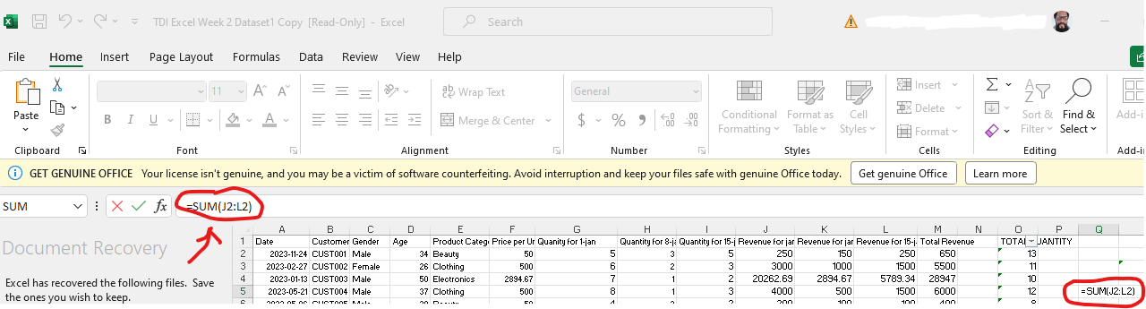 and drag it down to apply to all transactions.**=SUM(M2:M100) 655902.3291**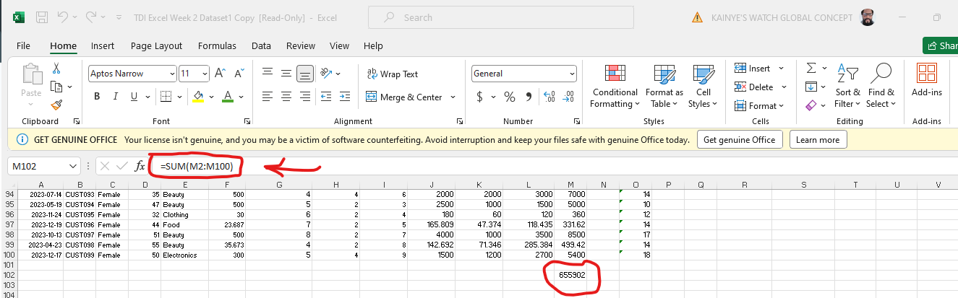

**Task 8: Calculate the sum of the total revenue for all transactions.**

In this case, I used the **SUM** function to add up all revenue values in the dataset.**=SUM(M2:M100) 655902.3291**

**Task 9: Calculate the product of the Jan-1 quantity and price per unit for the Food category.**

1. The task involves calculating the product of the **Jan-1 quantity** and **price per unit** for items in the **Food category** from a dataset.
2. Data Filtering:
   * Filter the dataset to include only entries from the **Food category** on **Jan 1**.
   * This ensures that only relevant data for the calculation is considered.
3. Calculation Process:
   * Multiply the quantity and price per unit for each entry in the filtered dataset.
   * This calculates the total cost of each item in the **Food category** on **Jan-1.**

**Task 10: Determine the average age of customers in the dataset.**

I used the **AVERAGE** function on the **Age** column to find the average age of customers.

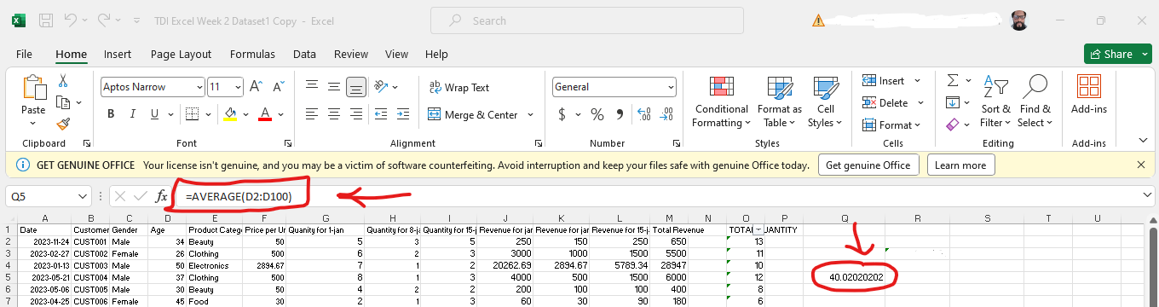

**Task 11: Round the total revenue to the nearest whole number.**

Rounding to Nearest Whole Number: Use the **ROUND** function.**=ROUND(655902, 0)**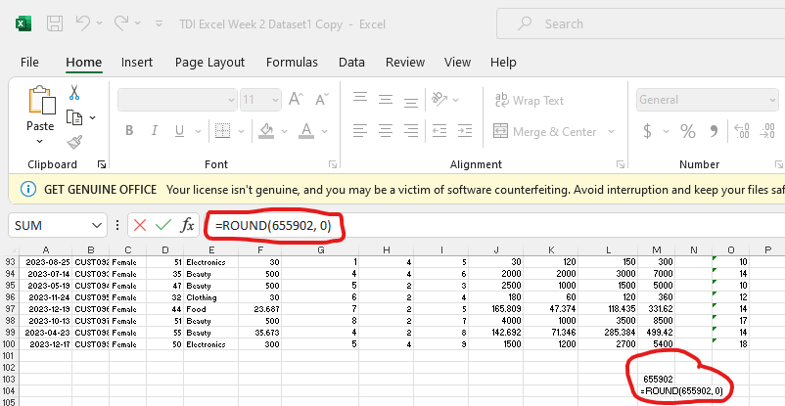

**Task 12: Round down the total revenue to the nearest integer.**

Rounding Down: Use the **ROUNDDOWN** function.**=ROUNDDOWN(655902, 0)**

**Task 13: Round up the total revenue to the nearest integer.**

Rounding Up: Use the **ROUNDUP** function.**=ROUNDUP(655902,0)**

**Task 14: What is the number of transactions in the dataset?**

Counting the Number of Transactions. **=COUNTA(UNIQUE(B2:B100)) =99**

**Task 15: What is total the number of non-empty cells in the "Product Category" column?**

Counting Non-empty Cells in the **"Product Category"** Column. **=COUNTA(E2:E100) =96**

**Task 16: Find the minimum age among the customers in the dataset.**

Use the **MIN** function on the age column to find the minimum age.**=MIN(D2:D100) =18**

**Task 17: Find the maximum total revenue among all transactions.**

Use the **MAX** function on the total revenue column to find the maximum revenue.**=MAX(M2:M100) =390522**

**Task 18: Calculate the square root of the total revenue.**

Use the **SQRT** function to find the square root of **Total Revenue**.**=SUM(M2:M100) =SQRT(655902) =809.878**

**Task 19: Raise the total revenue to the power of 2.**

Use the **POWER** function to raise total revenue to the power of 2.**=POWER(655902, 2) =4.30207E+11**

As I wrap up this project focused on Excel formulas, functions, and cell references, it’s clear that these tools are foundational to performing effective data analysis. I've explored everything from basic operations like addition and rounding, to more complex tasks like calculating total revenue and assessing demographic metrics such as age. I also touched on the distinctions between relative, absolute, and mixed cell references, highlighting their importance in building dynamic and robust spreadsheets.

Through these exercises, I've seen how Excel's powerful features can simplify complex analytical tasks, providing clear, actionable insights from raw data. This knowledge not only boosts efficiency but also enhances my ability to make informed decisions based on data.

As I move forward, I'm excited to see how I'll leverage these Excel skills to tackle more complex data challenges and uncover deeper insights. There's so much potential for growth, See you soon on another enriching adventure with Excel!